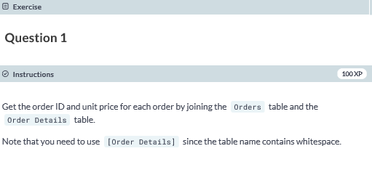

**SELECT o.OrderID, od.UnitPrice FROM dbo.[Order Details] AS od JOIN dbo.Orders AS o ON od.OrderID=o.OrderID;**

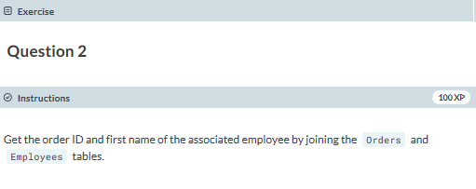

**SELECT o.OrderID, e.FirstName FROM dbo.Orders AS o JOIN dbo.Employees AS e ON o.EmployeeID=e.EmployeeID;**

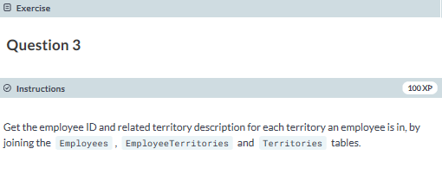

**SELECT e.EmployeeID, t.TerritoryDescription**

**FROM dbo.Employees AS e**

**JOIN dbo.EmployeeTerritories AS et**

**ON e.EmployeeID = et.EmployeeID**

**JOIN dbo.Territories AS t**

**ON et.TerritoryID = t.TerritoryID;**

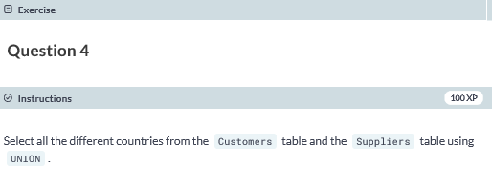

**SELECT DISTINCT Country FROM dbo.Customers**

**UNION**

**SELECT DISTINCT Country FROM dbo.Suppliers;**

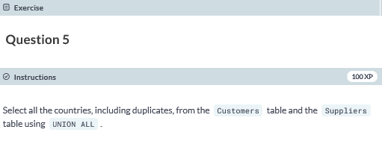

**SELECT c.Country FROM dbo.Customers AS c**

**UNION ALL**

**SELECT s.Country FROM dbo.Suppliers AS s;**

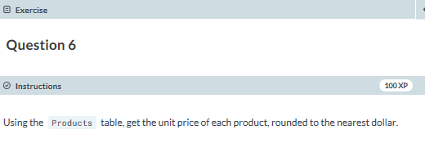

**SELECT ROUND(UnitPrice,0) AS UnitPrice FROM dbo.Products;**

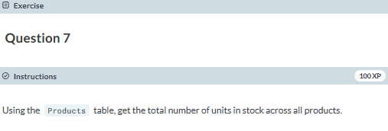

**SELECT SUM(UnitsInStock) AS TotalUnitsInStock FROM dbo.Products;**

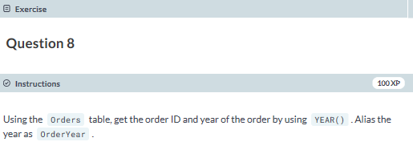

**SELECT OrderID,YEAR(OrderDate) AS OrderYear FROM dbo.Orders;**

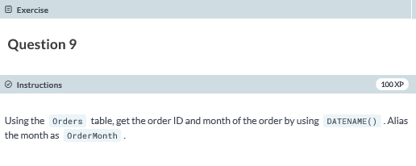

**SELECT OrderID, DATENAME(mm,OrderDate) AS OrderMonth FROM dbo.Orders;**

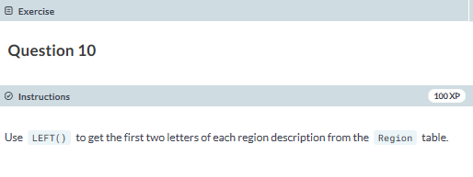

**SELECT LEFT(RegionDescription,2) FROM dbo.Region;**

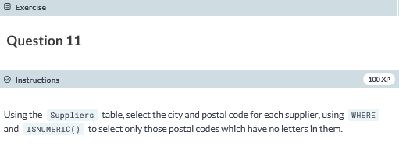

**SELECT City, PostalCode**

**FROM dbo.Suppliers**

**WHERE ISNUMERIC(PostalCode) = 1;**

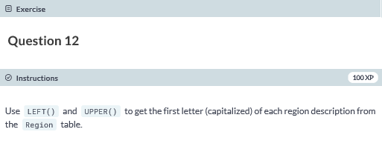

**SELECT LEFT(UPPER(RegionDescription),1) FROM dbo.Region;**